**THE PURPOSE OF RESEARCH IS TO**

Investigate existing situations or problems:   
Having followed the market, we realized that there is no place for private courses where they could create a course and conduct a lesson on the platform

To do this, we want to create a platform where you can upload video lessons and assignment to them and conduct high-quality lessons

**DIFFERENT TYPES OF RESEARCH:**

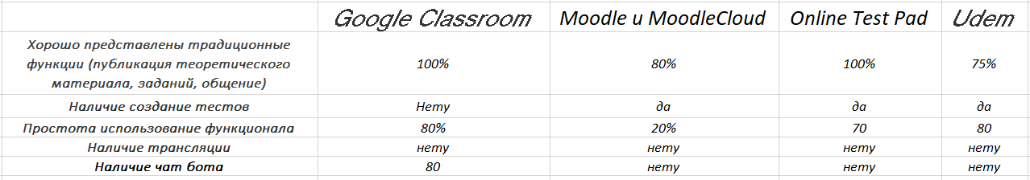

***Investigating our competitors, we want to make a very simple in functionality but very useful service for private courses  
There were such functions as video uploading like udemy and very clear functionality like a class room. Since our courses will be implemented for private courses, we want showing homework to a new level and so that we have the same chat as in teams.***

**RESEARCH APPROACHES:**

We assume that our project uses both Quantitative / Qualitative.

Because the design of our competitors will be very difficult for us to evaluate in Quantitative. This part we will use when check for example speed. While qualitative we will use when check design or etc.All of the functionality proceed from basic because all of the function that we want to use we take from the competitor comparison. From take all the comparison we create particular idea.

**Software design**

**We want to use microservices architecture.**

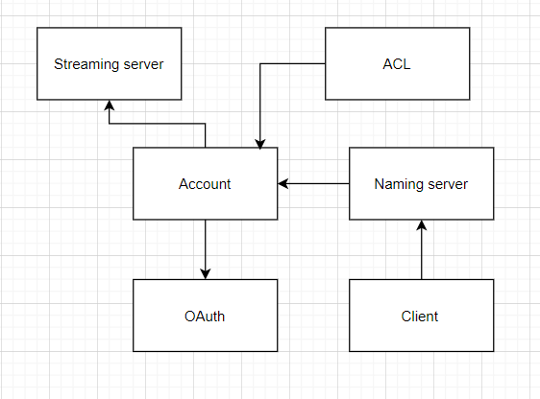

1. Сайт курса – будет основой, функционалом платформы здесь будем пользоваться (frontend)

2. Account – здесь будут все аккаунты, и все что связано с ним

3. OAuth – через сервис будет выдаваться токен и производится аутентификация

4. ACL – в сервисе будут описаны роли куда можем приписывать аккаунты. Ролям будем давать доступ на материалы (пример: С++, Java)

5. Streaming server – здесь будет дана возможность онлайн проведения занятия

6. Naming server – через сервис будет возможно взаимодействие остальных сервисов